**Retrieval-Augmented Generation (RAG)**

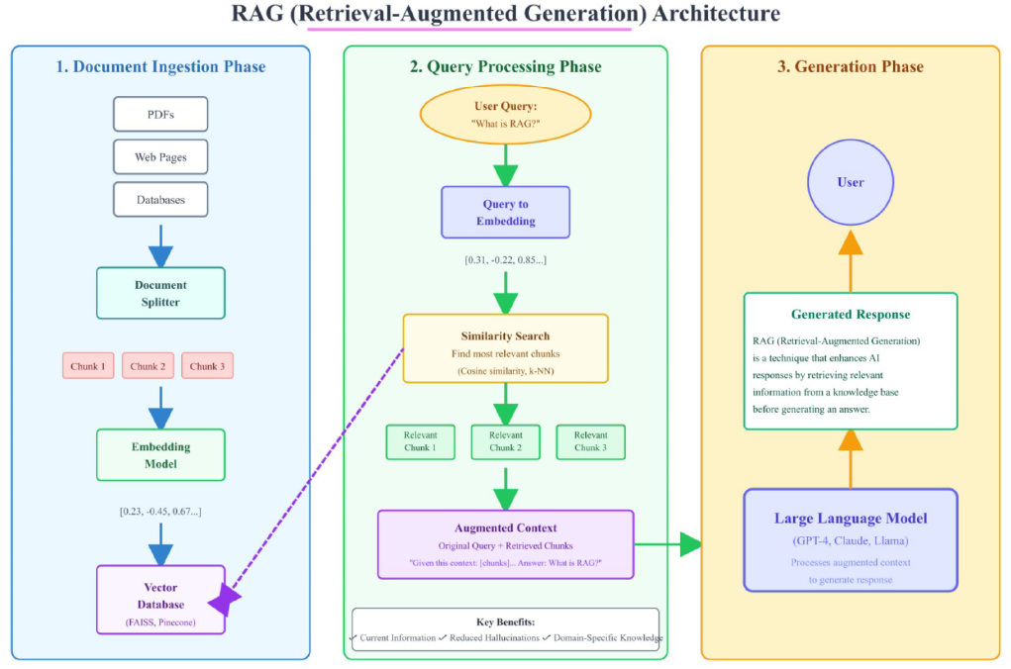

**🔹 What is RAG?**

* **Definition**: RAG (Retrieval-Augmented Generation) is a technique that enhances AI language models by combining their generative capabilities with **external knowledge retrieval**.
* **Analogy**:
  + Traditional LLMs = students in a **closed-book exam** (rely only on memory).
  + RAG-enabled models = students in an **open-book exam** (can look up references for more accurate, up-to-date answers).
* **Benefit**: AI can fetch specific, current, or specialized information from external sources instead of relying only on training data.

**🔹 RAG Workflow**

1. **Input Query** → User asks a question (e.g., “What is the current AI news?”).
2. **Retrieval** →
   * AI fetches relevant information from a **Vector Database** using similarity search.
   * Texts are converted into embeddings for search.
3. **Augmentation** → Retrieved content is **enriched with metadata** (e.g., source, date).
4. **Generation** → LLM uses the retrieved + enriched context to generate a final **accurate, contextual answer**.

**🔹 Example Use Cases**

* **Chatbot**:
  + Input: “What is recent leave policy of XYZ?”
  + Process: LLM retrieves HR policy documents → Enriches with metadata → Generates accurate policy response.
* **Customer Support**:
  + **Without RAG** → LLM provides vague, generic responses.
  + **With RAG** → AI retrieves company’s exact policy doc and generates a **specific, correct answer**.

**🔹 Illustration**

* **LLM as a Chef Analogy**:
  + Without recipe book = guesses (hallucination).
  + With recipe book (vector database) = retrieves right ingredients (data) → creates reliable output.

**🔹 Benefits of RAG**

1. **Cost Savings**:
   * JPMorgan saved $150M annually by using RAG for research instead of model fine-tuning.
2. **Accuracy**:
   * Microsoft saw a **94% reduction in hallucinations** in Copilot products with RAG.
3. **Flexibility**:
   * Bloomberg updates financial assistants **hourly** with new data → impossible with static models.
4. **Compliance**:
   * Healthcare firms use RAG to ensure AI responses always cite **approved medical sources**.

**🔹 Example: Customer Support**

* **Without RAG**
  + Customer: “What’s your return policy during Black Friday?”
  + AI: “Generally, most companies offer 30-day returns…” (generic, unhelpful).
* **With RAG**
  + Customer: “What’s your return policy during Black Friday?”
  + AI: “According to Policy Doc v3.2 (updated Nov 2024), Black Friday purchases have an extended 60-day window until Jan 31st. Electronics → 15-day return. Do you want me to start a return?” (specific, accurate).

**🔹 Business Impact**

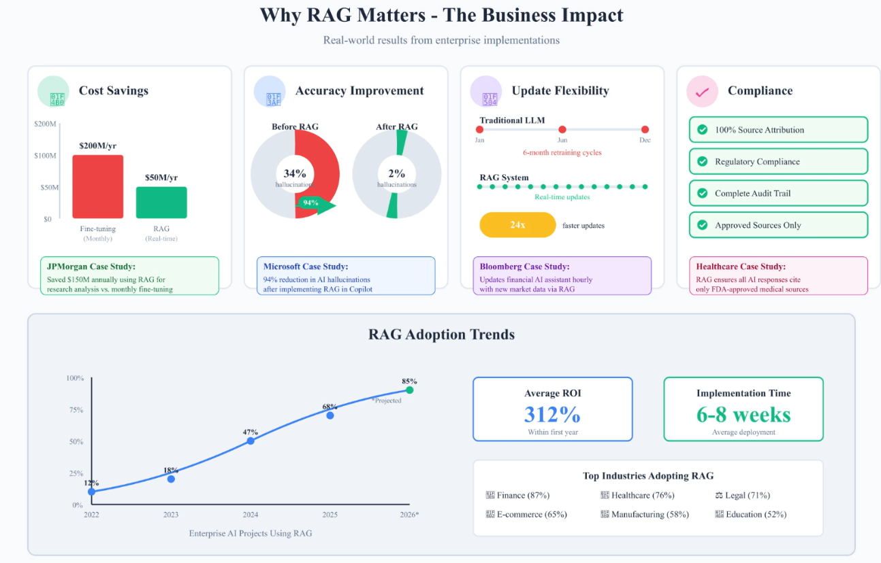

✅ **Summary**:  
RAG improves LLMs by **retrieving**, **augmenting**, and **generating** responses with accurate, real-world context. This reduces hallucinations, cuts cost, ensures compliance, and makes AI assistants reliable for **enterprise and production-grade use cases**.

**🔹 Prompt Engineering vs Fine Tune vs RAG**

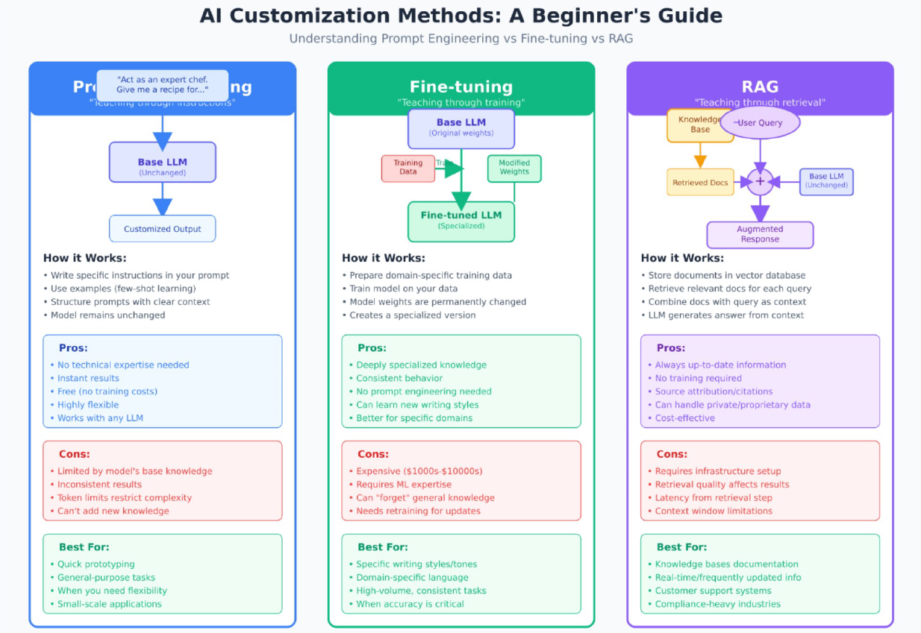

**Document Ingestion and Preprocessing (RAG Pipeline)**

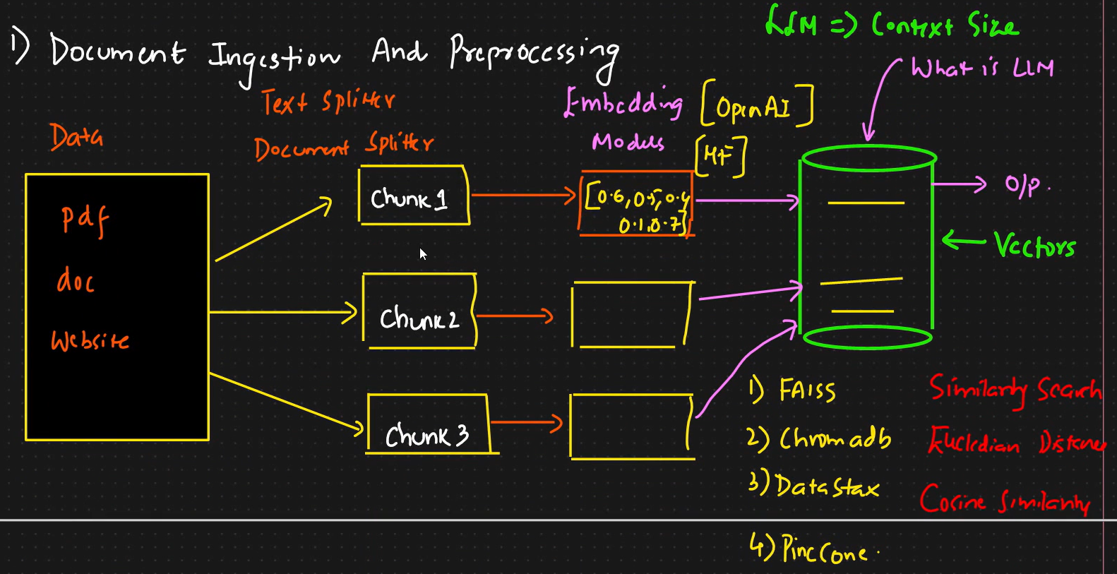

**🔹 Step 1: Data Sources**

* **Why multiple sources?**  
  In real-world enterprise scenarios, knowledge isn’t stored in one uniform format. Important company information can be scattered across **policy documents, contracts, annual reports, research papers, customer support manuals, or even dynamic websites**. To make the AI assistant effective, all these sources must be ingested into a unified knowledge pipeline.
* **Typical inputs:**
  + **PDFs** – financial reports, research publications, scanned documents.
  + **DOC/DOCX** – HR policies, internal memos, legal documents.
  + **Websites** – FAQs, support portals, news/blog updates.
  + (Extendable to CSVs, Markdown, HTML, JSON logs, etc.)

👉 The goal is to **normalize all heterogeneous formats** into a machine-processable text stream.

**🔹 Step 2: Splitting (Chunking Strategy)**

* **Why split?**  
  LLMs cannot process entire books or long documents directly because of **context window limitations**. Large files need to be broken down into smaller, semantically meaningful pieces.
* **How splitting works:**
  + **Text Splitter** – Breaks down plain text based on character count, paragraphs, or semantic boundaries.
  + **Document Splitter** – Specialized tools for parsing PDFs, Word files, or HTML pages while preserving structural meaning.
* **Example:**
  + A 50-page HR manual could be split into ~500 chunks of ~500 tokens each.
  + Each **chunk** becomes an independent retrievable unit, e.g., Chunk1 (leave policy), Chunk2 (payroll rules), Chunk3 (health benefits).

👉 Splitting is crucial for ensuring that **retrieval retrieves specific context**, not entire documents.

**🔹 Step 3: Embedding (Vectorization)**

* **Purpose:**  
  Converting textual data into **high-dimensional numerical vectors** that capture semantic meaning.
* **Embedding Models:**
  + **OpenAI embeddings** (e.g., text-embedding-ada-002) → widely used for production-grade RAG.
  + **HuggingFace (HF) embeddings** → open-source models like SentenceTransformers (BERT, MiniLM, etc.).
* **Output Example:**
* Text: "Revenue increased by 10% in 2023"
* Vector: [0.62, 0.58, 0.41, 0.93, 0.12, ...]

👉 Now each chunk is represented by a **dense vector** that can be compared to query vectors using similarity measures.

**🔹 Step 4: Vector Database (Storage & Retrieval Engine)**

* **Why not use SQL/NoSQL?**  
  Traditional databases are optimized for exact matching (e.g., WHERE name=‘X’). They are not designed for **semantic similarity search**. A vector DB is required to efficiently handle high-dimensional embeddings.
* **Popular Options:**
  1. **FAISS** – Open-source, fast similarity search library (Facebook AI).
  2. **ChromaDB** – Lightweight, popular with LangChain integrations.
  3. **DataStax** – Enterprise-grade, scalable vector storage.
  4. **Pinecone** – Managed vector DB service, scalable and production-ready.

👉 These systems store embeddings and support high-performance **nearest neighbour searches**.

**✅ Extended Summary**

The ingestion and preprocessing pipeline is the **foundation of RAG**:

1. **Ingest diverse data sources** (PDF, DOC, Websites, etc.).
2. **Split into manageable chunks** so they fit into LLM context.
3. **Convert chunks into embeddings** using OpenAI/HF models.
4. **Store embeddings in a vector database** optimized for semantic search.

This pipeline ensures that **retrieval is accurate, efficient, and production-ready**, enabling LLMs to provide **contextual, factual, and up-to-date answers** instead of generic hallucinations.

**📘 Query Processing Phase (RAG Pipeline)**

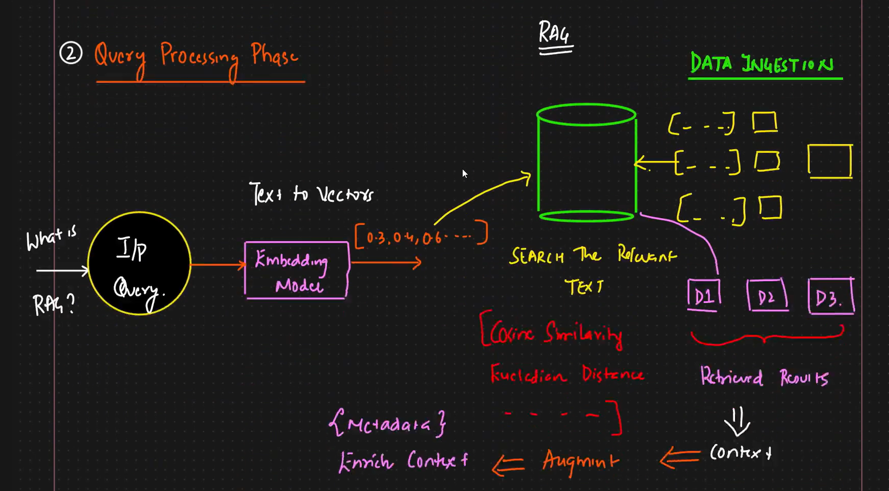

**🔹 Step 1: Input Query**

* **Process:**
  + The user initiates a request in plain language, e.g., *“What is RAG?”*.
  + This query could come from a **chatbot**, **search assistant**, **API call**, or even voice-to-text pipeline.
* **Why important?**
  + Unlike SQL queries (structured), user queries are **unstructured and ambiguous**.
  + The system must make them machine-understandable while keeping the semantic meaning intact.
* **Challenges:**
  + Queries may be vague (*“Tell me about revenue”*) or too specific (*“Tesla’s net revenue in Q2 2023”*).
  + Need to handle synonyms, abbreviations, and domain-specific jargon.

👉 **Key role**: Convert *human-friendly query* → *machine-friendly representation*.

**🔹 Step 2: Embedding Model (Text → Vector Conversion)**

* **Purpose:**
  + Convert the query into a **vector embedding** — a dense numerical representation.
  + Embeddings capture **semantic meaning**, not exact words.
* **Example:**
* Input: "What is RAG?"
* Embedding: [0.32, 0.40, 0.65, 0.11, 0.88, …]
* **Why embeddings work:**
  + *“What is RAG?”* and *“Explain Retrieval-Augmented Generation”* map close in vector space.
  + Traditional keyword search would fail, as words differ.
* **Common models:**
  + **OpenAI** – text-embedding-3-small/large → optimized for speed & accuracy.
  + **HuggingFace Transformers** – Sentence-BERT, Instructor models.
  + **Cohere / Google Vertex AI** – enterprise-grade embeddings.
* **Trade-offs:**
  + OpenAI embeddings → easy, high-quality, but cost per API call.
  + HF embeddings → open-source, self-hosted, but require infra scaling.

👉 This step ensures the query and stored chunks are **comparable on meaning, not keywords**.

**🔹 Step 3: Vector Database Lookup**

* **Purpose:**
  + Store embeddings of all document chunks (created during ingestion).
  + Compare the query embedding against these stored embeddings.
* **Process:**
  + Convert query into vector.
  + Search in vector DB for **nearest neighbors** (most similar vectors).
  + Retrieve top-k most relevant chunks.
* **Similarity Techniques:**
  + **Cosine Similarity** – Measures angle between vectors (semantic closeness).
  + **Euclidean Distance** – Straight-line distance (good for numeric similarity).
  + **Dot Product / Inner Product** – Efficient scoring in some systems.
* **Vector DB Options:**
  + **FAISS** → fast, local, research use.
  + **Pinecone** → managed SaaS, scalable, production-ready.
  + **Weaviate, Chroma, Milvus** → popular in GenAI stacks.
  + **ElasticSearch/OpenSearch with vector support** → hybrid keyword + semantic search.

👉 This is the **heart of RAG** — finding *relevant context* among thousands of chunks.

**🔹 Step 4: Retrieval Results**

* **Output Example:**
  + Query: *“What is RAG?”*
  + Retrieved Chunks:
    - **D1:** “RAG enhances LLMs with external knowledge sources.”
    - **D2:** “RAG combines Retrieval + Augmentation + Generation.”
    - **D3:** “RAG reduces hallucinations by grounding answers in documents.”
* **Challenges in Retrieval:**
  + May pull **too many irrelevant chunks** (noise).
  + Risk of **semantic drift** → relevant but off-topic chunks.
  + **Latency trade-off** → larger DBs require optimized search indexes.
* **Optimizations:**
  + Use **Top-k filtering** (e.g., top 3–5 chunks).
  + Apply **reranking models** (cross-encoders, LLM re-rankers) to reorder results.
  + Use **hybrid search** (keyword + semantic) for higher precision.

👉 Good retrieval = accurate, concise, and contextually aligned with the query.

**🔹 Step 5: Augmentation (Enriching Context)**

* **Why Augment?**
  + Raw chunks lack context — e.g., “Revenue increased by 10%” → doesn’t tell *when, where, or source*.
  + Metadata ensures answers are **trustworthy and transparent**.
* **Metadata examples:**
  + **Source** → “Tesla Annual Report 2023”
  + **Date** → “July 2023”
  + **Author/Dept** → “HR Policy Doc, XYZ Corp.”
  + **Confidence score** → “0.92 similarity”
* **Benefits:**
  + Reduces hallucinations (model can cite actual sources).
  + Improves compliance (healthcare, finance must always reference approved docs).
  + Enables advanced features like **traceable citations** and **auditing**.

👉 Augmentation = moving from “just retrieval” → “trustworthy retrieval”.

**🔹 Step 6: Final Context Assembly**

* **Why needed?**
  + LLMs have **context size limits** (e.g., 16k → 128k tokens).
  + You cannot dump 100 documents; must carefully select & structure context.
* **Strategies:**
  + **Top-k selection** – choose the most relevant chunks.
  + **Summarization layer** – condense chunks into a short version.
  + **Hierarchical retrieval** – multi-stage pipeline (broad retrieval → focused filtering).
* **Example Context Package:**
* Context:
* [Source: Research Paper, 2023]
* RAG (Retrieval-Augmented Generation) enhances LLMs by combining
* external knowledge retrieval with generative capabilities.
* It reduces hallucination and provides up-to-date, accurate answers.

👉 This context package is what gets injected into the **LLM prompt**, enabling it to answer based on **retrieved facts, not guesses**.

**✅ Extended Summary**

The **Query Processing Phase** transforms user queries into enriched, fact-grounded inputs for LLMs:

1. **User Query → Vector Embedding** (semantic representation).
2. **Vector DB Lookup** retrieves the most similar chunks using cosine or Euclidean distance.
3. **Retrieved Results** (D1, D2, D3) provide raw context.
4. **Augmentation** enriches results with metadata for trust and transparency.
5. **Final Context Assembly** builds a compact, LLM-ready input within context window limits.

⚡ **Enterprise Value:**

* **Accuracy** → Relevant, factual answers.
* **Compliance** → Traceable to source.
* **Efficiency** → Fits within context size.
* **Trust** → Reduces hallucinations and increases reliability.

👉 Query Processing is the **bridge between user intent and knowledge grounding**, ensuring RAG-based systems deliver **precision, transparency, and enterprise-grade reliability**.

**📘 Generation Phase (RAG Pipeline)**

**🔹 Step 1: Input Assembly**

* **What happens before generation?**
  + The system combines:
    1. **Original Query** (user’s actual question).
    2. **Enriched Context** (retrieved document chunks + metadata, augmented in the previous phase).
* **Why both?**
  + The **query** ensures the LLM understands user intent.
  + The **context** grounds the response in factual data retrieved from the knowledge base.

👉 The combination makes the prompt **rich, precise, and verifiable**.

**🔹 Step 2: Feeding into the LLM**

* **LLM receives a composite input:**
* User Query: "What is RAG?"
* Context:
* - Source: Policy Doc v3.2, Nov 2024
* - "RAG enhances LLMs by combining external retrieval with generation."
* - "It reduces hallucinations and improves accuracy."
* **Effect:**
  + Without context → LLM may guess or hallucinate.
  + With enriched context → LLM generates grounded, explainable answers.

👉 This step transforms **raw data** into **usable knowledge** inside the LLM’s reasoning process.

**🔹 Step 3: Generation Process**

* **LLM role:**
  + Takes query + context.
  + Synthesizes a **final coherent response**.
  + Produces **summarized output** aligned with user intent.
* **Characteristics of the generated answer:**
  + **Grounded** – Based on retrieved docs, not just memory.
  + **Contextual** – Uses metadata (time, source, reliability).
  + **Concise & Summarized** – Strips away irrelevant detail, delivers clarity.
* **Examples of Supported LLMs:**
  + **OpenAI GPT models** → widely used for RAG (e.g., GPT-4, GPT-4o).
  + **Anthropic Claude** → excels in summarization & long context.
  + **Meta LLaMA / Mistral** → open-source, tunable for enterprise.
  + **Google Gemini** → multimodal retrieval + generation.
  + **CROQ / specialized models** → optimized for ultra-low latency retrieval + inference.

👉 Generation is **model-agnostic**; any LLM can be plugged into the pipeline.

**🔹 Step 4: Summarized Output**

* **Final Response Characteristics:**
  + **Direct** → Answers the original query.
  + **Traceable** → Can cite the source doc.
  + **Summarized** → Avoids overwhelming the user with raw chunks.
* **Example:**
  + **User:** “What is RAG?”
  + **AI (with RAG):**

“RAG, or Retrieval-Augmented Generation, is a method where LLMs combine external document retrieval with text generation. This ensures responses are accurate, up-to-date, and less prone to hallucinations. (Source: Policy Doc v3.2, 2024)”

👉 Summarization converts **multiple chunks of raw knowledge** into a **single, digestible, user-ready answer**.

**🔹 Step 5: Key Considerations in Generation**

1. **Context Window Limitations**
   * Large LLMs have token limits → must select only top chunks.
   * Use **prompt compression** and **summarization layers**.
2. **Faithfulness to Context**
   * Must avoid “over-generation” beyond retrieved knowledge.
   * Add **guardrails** to restrict hallucination.
3. **Response Style Customization**
   * **Customer Support** → polite, short, action-driven.
   * **Research Assistant** → detailed, technical, citation-heavy.
   * **Enterprise Reporting** → structured (tables, bullets).

👉 Generation is where **retrieval + augmentation meet user experience**.

**✅ Extended Summary**

The **Generation Phase** is the final stage of the RAG pipeline. It ensures that:

1. **Original Query + Enriched Context** are combined into one input.
2. The **LLM** processes this structured input instead of guessing.
3. The **output** is summarized, factual, and aligned with the query.
4. Supports multiple LLM backends (OpenAI, Anthropic, LLaMA, Gemini, etc.).
5. Ensures enterprise-grade qualities: **accuracy, transparency, summarization, compliance**.

⚡ **Enterprise Value:**

* **Reliability** → grounded in real docs.
* **Efficiency** → summarized for easy consumption.
* **Flexibility** → adaptable across industries (finance, healthcare, legal).
* **Compliance** → citations + metadata provide audit trails.

👉 The Generation Phase is the **delivery layer** of RAG, turning context-rich inputs into **actionable, trustworthy answers**.